

Welcome to
St Thomas’
A Guide for Families in Nursery

Address
South Park
Sevenoaks, TN13 1EH

Phone
01732 453921

Website
http://www.saintthomas.co.uk

Email
office@st-thomas-sevenoaks.kcsp.org.uk
nursery@st-thomas-sevenoaks.kcsp.org.uk

Dear Family,
We warmly welcome you to St Thomas’ Catholic Primary School part of Kent Catholic Schools Partnership. This booklet is designed to introduce you to the school and help you to feel right at home!
Our Mission
As a Catholic school, we work with the whole community to promote the well-being of every child and family. From this secure foundation, we nurture every child’s development as a learner to become a skilled and creative individual who is able to make a positive contribution to society. At St Thomas’, everything we do is guided by the following school mission:


We are a Catholic School
The Catholic life of the school is rich in opportunities for children to encounter God and to deepen their relationship with Him as a loving, compassionate Father. Through prayer, liturgy, Religious Education lessons, and the relationships and support for each other we enable children to come to know and love God. Prayer is central to the daily life of our school.
In this way we aim to help the children to come to value and respect the power of prayer and its place in their relationship with God. The key events of the liturgical year are celebrated in many forms such as whole school Masses, Christmas Carol Services, Nativity performances, Lenten devotions including Reconciliation, Passion play, feast day celebrations, the Rosary.

Staff
Ms Leahy  Headteacher |  | Mrs O’Keefe  Secretary and Admissions
Mrs Motta  Finance Officer |  | Mrs Bosworth  Nursery Administration & Extended School
Teacher |  | Teaching Assistant
Miss Allen & Mrs Tan  Nursery |  | Mrs Ruyant  Mrs Masters  Miss Brown
Miss O’Keefe  Year R Class Teacher |  | Mrs Couldwell
Mrs Bourke and Mrs Dewell  Y1 Class Teachers |  | Mrs Yule  Mrs Ahern
Mrs O’Keefe Parr and Mrs Donoghue  Y2 Class Teachers |  | Mrs Betts
Mrs Busvine and Mrs Carlton  Y3 Class Teacher |  | Mrs Way
Miss Tsang  Y4 Class Teacher |  | Mrs Roberts
Mrs Fromings and Miss Serratosa-Rojas  Y5 Class Teacher |  | Mrs Brennan
Mrs Williams  Y6 Class Teacher |  | Miss Serratosa-Rojas
Mrs Carlton
Music Teacher
Mrs Stevens,  Mrs Debie, Mrs Lucken, Mrs Perry, Miss Brown Extended Care |  | Mrs Eastwood  Lunchtime Supervisor  Extended Care

How We Communicate with You
Website
The address is http://www.saintthomas.co.uk where you will find a great deal of information including curriculum, policies, important dates, newsletters and blog. Please check the class pages on the website for any news from the class teacher. Please use the calendar on the website for forthcoming events.

Parentpay
ParentPay is a secure online payment system that replaces cash payments for school meals, trips, events and activities in our school and nursery. ParentPay is easy to use, secure and protects your details.
Signing up for ParentPay: if you have supplied your email address to the school an email will automatically be sent to you with a link and password to login to the system.
Through ParentPay you will receive:
- Newsletters
- School trips information
- Clubs information (excluding After School Club and Breakfast Club)
- Class newsletters
- Parents’ Evening information
- Girls’ summer dresses purchasing instruction

Newsletters (via ParentPay)
- Teacher’s fortnightly newsletter. This is filled with photographs of the children’s learning. The email will contain a Microsoft Sway link to access the content.
- The second comes from the Headteacher and contains news about our recent events and important dates for your diary, including term dates. These newsletters will also be available on the school website and in hard copy in the noticeboard by the school gate.
- Tapestry memos. The Nursery will post important updates and information in the form of a memo on our learning platform ‘Tapestry’ where we will also post observations of the children for those ‘wow’ moments.
- Please also check the board outside the school gate for any last-minute arrangements or reminders.

Please provide the school with your correct email address and mobile telephone number. We use email to send the newsletter and other information, and we use ‘Texts’ to send urgent messages (we promise not to flood your inbox!).

The School Day
The school gate opens at 8.30am. Children should enter the gate at the latest at 8.45am, to ensure they are on time to begin lessons at 8:45am. Any child arriving late should enter the school by the office and make sure the office staff are made aware of their arrival. We ask parents to make every effort to ensure their child is in school on time as being late is disruptive to the late child, teacher and other pupils.

The school day ends at 3.15pm. Please ensure that children are collected promptly as it can be very upsetting for them to be ‘left behind’. If, in exceptional circumstances, you are running late to pick up your child, please call the office as soon as possible to let us know. If you have not arrived by 3.30pm your child will attend After School Club and a charge will be added to your Parent Pay account. Children are required to be collected by a responsible adult. If your child is to be collected by someone other than their main carer, please let the school know in advance and email a photo of the person to the office, otherwise we will not be able to release them.

Wrap-Around Care (Extended School)
The school offers a Breakfast Club and an After School Club. With the extended hours, the school day starts at 07:30 until 18:00. Should you wish to book your child into Breakfast Club or After School Club please email: extendedschool@st-thomas-sevenoaks.kcsp.org.uk
Breakfast Club runs from 07:30 to 08:30. Pupils get ready to go to class at 08:15 so please ensure your child arrives in plenty of time to eat their breakfast.
After School Club runs until 18:00. Please be on time to collect your child.

Both Breakfast Club and After School Club are attended by all year groups, so that children from Nursery to Y6 will have the opportunity to be together whilst the activities will cater for different learning stages and interests. Collaboration between older and younger children is actively encouraged as it is important to our school that children are respectful and kind to each other across all age groups.

Healthy Eating
Packed lunches
Please note that if your child is staying for a full day in Nursery, you will need to provide them with a nut free and sesame free packed lunch which they eat with their class in the EYFS block. Remember to send your child’s lunch in a washable, reusable container.

Snacks
As part of the Government initiative, Nursery children are provided with a free piece of fruit or vegetable as a snack. In addition, we ask parents to support our healthy eating policy by providing a healthy carbohydrate snack such as rice cakes, breadsticks, crackers, oat cakes etc. Snacks should be provided in a washable, reusable container clearly labelled with your child’s name.

Drinks
Please make sure that your child brings a NAMED water bottle to school every day. Bottles will be sent home each day for washing.

School Car Park
The school car park is for use by members of staff only. As the car park is in constant use, please help us keep you and your child safe by using the pedestrian walkway at the beginning and end of the day. If you travel to school by car, please either park on a designated parking space on the road or in South Park Car Park. Please be mindful of our road layout and parking regulations. Selfish parking puts other children’s lives at risk.
What to do if your child is sick
Please call the school by 9:15am if you have decided to keep your child off school due to illness.
We ask that you carefully consider whether keeping your child off school is the best solution, as any absence will be detrimental to their education. Colds and other minor illnesses are not reasons to stay at home. However, if your child has had diarrhoea or has been sick, they must be symptom free for at least 48 hours before returning to school. Your co-operation in helping prevent the spread of infectious illnesses throughout the school is appreciated.
If a child becomes sick in school, for example they develop a temperature or vomit, we will call you. It is important, therefore, that we have up-to-date contact numbers.
Medicine: We do not routinely administer medicine to children in school, so please speak to the office staff if you think your child needs to be given medicine during the school day.
Leave of Absence
No leave of absence for holiday during term time will be authorised. The exception is for parents who can only take holidays in term-time, or when a family needs to spend time together to support each other during or after a family crisis e.g. bereavement. Such requests need to be made in writing to the Headteacher, detailing in full the reason for the request.

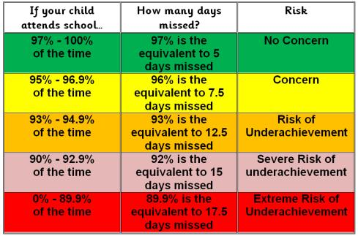

School Uniform
Details of our school uniform are below and can be found on our website. Uniform can be bought at Horncastles on Sevenoaks High Street or through their website www.horncastles.co.uk.
Good quality second-hand uniform is also available during occasional sales on the playground.

Please make sure all items are clearly named. This can prevent a child becoming upset if things go missing and saves a great deal of our time!
Please ensure that you child has the appropriate shoes and clothes for outdoor play, whatever the weather.

Winter  From: Beginning Autumn Term 2 (After October half term) To: end of Spring Term 2 (before the Easter Holidays) | Summer  From: Beginning Summer Term 1 (After Easter Holiday) To: End of Autumn Term 1 (Until October half term)
ALL UNIFORM MUST BE NAMED OR WE WILL BE UNABLE TO RETURN ANY ‘LOST’ ITEMS.
EYFS – Nursery | EYFS – Nursery
- Navy blue jogging bottoms/leggings  - Pale blue long-sleeved polo shirt  - Maroon sweatshirt (Horncastles)  - Navy or grey socks  - School fleece (Horncastles)  - Navy or black warm, waterproof coat  - Sturdy Velcro footwear  - Wellington boots (any colour/pattern) | - Navy blue shorts  - Pale blue short-sleeved polo shirt  - Maroon sweatshirt (Horncastles)  - Navy or grey socks  - Navy or black lightweight waterproof coat  - Black shoes – not trainer type  - Sturdy Velcro footwear  - Sunhat with a brim
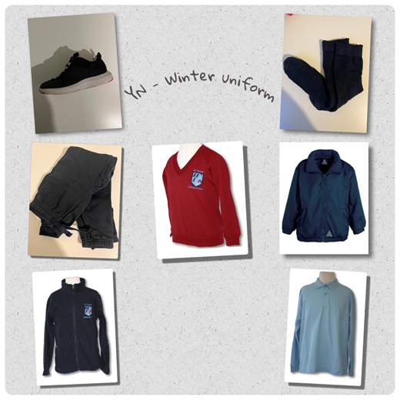 | 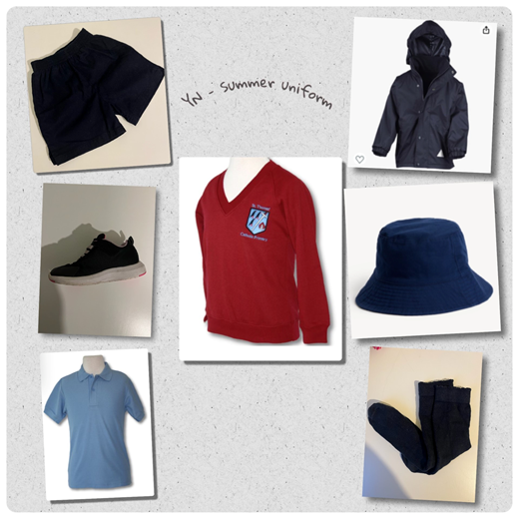

School Bags and Snack Bags
Children in Nursery need a drawstring bag in order to keep a spare set of clothes in. This must include pants, socks, trousers, a top, a jumper and spare shoes. Children regularly have accidents, either toilet related, or from water play, spilling drinks at snack time etc. and this is to be expected, so a spare set of everything, including footwear is needed! The bag will be kept in school on your child’s peg and we will only send it home if they have had to change into their spare clothes. They will need a SMALL rucksack to carry their water bottle, snack and lunch in, and for taking home any work they make.

 | Rucksack | Lunchbox/bag  (any) | Gym bag  (spare clothes)
Nursery | ✅ | ✅ | ✅
Y R & Y 1 | ❌ | ✅ | ✅
Y 2, 3, 4, 5 & 6 | ✅ | ✅ | ✅

Behaviour and House Token System
Pupils are assigned to a ‘House’ at St Thomas’. These are named after four saints:
 | 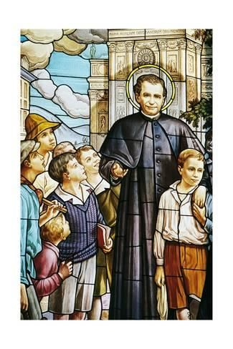 |  | 
Porres House  (St Martin de Porres, Ruby) | Bosco House  (St John Bosco, Topaz) | Seton House  (St Elizabeth Seton, Sapphire) | Cabrini House  (St Frances Cabrini, Emerald)

Pupils can earn tokens for their House when staff observe them following rules or doing a kind deed. Siblings are allocated to the same house. Houses are used at Sports’ day and during other projects when children are grouped across the school to work with children of other ages in a spirit of co-operation and support.

There is an assembly each week to celebrate the school values and catholic social teaching. Merit certificates will be awarded to reflect school virtues. Certificates are awarded to individuals who have made a special effort and the weekly house points total is announced.

Parent Voice and Getting Involved
Parents and teachers
Parents are encouraged to have regular contact with their child’s class teacher. In the afternoon staff accompany their class to the playground and you are welcome to speak to the teacher on an informal basis there. If required, appointments can be made at a mutually convenient time with any member of staff, who can be contacted via the school office.

Help us to improve
We regularly ask for feedback through surveys which are accessible through the school website, and a link to them will be sent out via email.

Meet the Governing Body
The role of Members of the Governing Body is to support the school, being prepared to account for the school’s overall performance. Members also act as ‘critical friends’, which means offering constructive advice, a sounding board for ideas, a second opinion on proposals and help where needed. Members are there to set the school’s ethos and strategic direction. They are also expected to hold the Headteacher to account for the performance of staff and children, and to ensure that public money is being well spent.

Parent Teacher Association
Parents are automatically members of the Parent Teacher Association (PTA). Please do attend meetings to see how you can help out with fundraising and supporting the school.

Parental Support
We welcome parental support at school. If you have any free time, please let your child’s class teacher know and we can make suitable arrangements, which may not necessarily be in your child's class. You will be asked to complete a police check (DBS) form.

Curriculum
At St Thomas’, we follow the Early Years Foundation Stage (EYFS) Curriculum in Nursery and Reception and the National Curriculum in Key Stage 1 (Years 1 and 2) and Key Stage 2 (Years 3-6).

We structure our curriculum in all years through a ‘creative curriculum’. This means that we select a main topic and teach all subjects in the context of that topic. We often select topics based upon the enthusiasms and interests of the children themselves.
Every half term (6 weeks) teachers will send parents a ‘topic map’ detailing the planned learning for the topic.

Every 6 weeks, children’s progress is discussed and tracked by the Senior Leadership Team (SLT) in conjunction with the class teacher.

Special Educational Needs
All children are different, and teachers differentiate each lesson to cater to all learning styles and needs in their class. Some children may be identified by the school as having ‘Special Educational Needs’. The school supports all pupils in the following way:
- In the second week of each term the Headteacher and SENCO meet with all class teachers to discuss the progress of all children. Class provision plans are then written to ensure that all necessary support is put in place, assessed and reviewed.
- This review meeting will lead to children being assessed by the SENCO team in the classroom.
- If necessary the school will send home a school concern form. This may lead for further assessment of a child’s needs. Some children then have an individual provision plan, others go on to be supported with an Education Health Care Plan, depending on need.
- Parents sometimes seek assessment of their children from other agencies. The results of these assessments will be discussed at the termly meeting. A meeting between the SENCO team and parents will then be arranged.
- Parents of all children who have an individual provision plan will meet with the class teacher (either in person or on zoom) three times a year to discuss their child’s needs.
The school employs a SALT (speech and language therapist) and an OT (occupational therapist) directly so that we are able to support our children as quickly as possible.
If you have any queries please email the Headteacher or the SENCO or make an appointment to meet your child’s teacher at a mutually convenient time.

Prayer and Liturgy and Performances
We hold a number of masses, special performances, church services and concerts throughout the year. The details of these will appear in the newsletter. Look out for our Harvest Festival, Christmas Carol Service, Nativity and Music Concert.

Trips and Residential Visits
St Thomas’ is committed to providing a creative and varied curriculum for your child(ren). We regularly take the children out of school to learn in different environments, making use of the many wonderful local facilities. We ask parents to complete online consent form when their child starts at St Thomas’, which covers us for all day trips. We will always let you know well in advance of any day trips so that you know your child will be going off-site, and what they will need to bring. We will sometimes ask for a voluntary contribution towards a trip.

We are very fortunate that the PTA provides some funding towards the cost of these trips.

Frequently Asked Questions

Can children bring personal property in school (including pencil cases, playing cards, phones, toys, games)? | No – personal items will be put in a safe place by staff and returned to parents (not children) at the next possible opportunity. The school cannot take responsibility for loss or damage to any personal property.
How do we communicate with parents | Weekly newsletter from the Headteacher. Weekly SWAY newsletter showcasing the children at school that week.  Termly class newsletter – emailed directly to parents and also available on the website.  Class WhatsApp group. Parents set up WhatsApp groups and class reps are appointed. This is likely to take place shortly before the beginning of the next school year, or during the first week of the school year.
How do we get access to the newsletters and other emails? | By signing up to ParentPay.
How do we pay for school meals, clubs etc? | Via ParentPay
How do we sign up to ParentPay? | Please provide the school office with your designated email address. Only the parent signed up with ParentPay will receive the newsletter, so if both parents wish to receive the newsletter directly, they will have to both register with ParentPay. Alternatively, they can set up an auto-forwarding rule in their inbox.
Where do we hand in forms and letters? | All letters or forms, whether for the class teacher or the school office, should be handed in by your child to their class teacher at morning registration, not taken to the school office. To support our efforts to be more environmentally friendly, please only send notes, letters or forms in an envelope if it contains a cheque, money or confidential information.  Most correspondence is sent home via our email system. If you are unable to print any forms sent to you electronically, please collect a copy from the school office.
Can we celebrate birthdays at school and bring cakes/party bags? | We love to celebrate birthdays at school and welcome birthday treats, however there are a few rules:  - Muffins, cupcakes, fairy cakes, haribo and biscuits are the best option if you want to send in a treat for the class to share (as they don’t need to be cut up).  - For all of the above, if it has sesame, nuts or traces of nuts, we cannot accept it in school. Please also take into account any other allergies within the class e.g. dairy free.
How can we speak to teachers when the child has an issue? | Arrangements can be made at pick up and drop off, and the office can facilitate individual meetings. Please let us know if you have any concerns about your child, as we would rather know as soon as possible.
Does the sunhat need to be from Horncastles? | No, any sun hat with a brim all the way round would do.
When are the teachers/parents evening? | These are usually during Term 2 and Term 4. Dates will be announced in the newsletter via ParentPay. The newsletter will contain a link to the available 10-minutes slots that will be booked online.
We lost our belongings. Who can we contact? | Named items will be returned to the relevant pupil. Any unnamed lost property can be reported to the school office. We do not have a ‘lost property’ box. Lost snack boxes can be found at the school gates. Clothing is left outside the Headteacher’s Office where children can look during the day. Any unclaimed items will be hung from the school gate for parents to check at pick-up and drop-off.
With snow, will the school be open? | It depends – we will make every effort to update the website first thing to let parents know if the school will be open or not.
What will pupils do during Breakfast and Afternoon club? | The pupils will be involved in age-appropriate games and activities. Please speak to a member of staff for details.

Above all…
Your child’s experience at school should be a happy and successful one. Please let us know if you have any concerns about your child. We would rather know as soon as possible if your child is having any difficulties, so speak to the class teacher as soon as you can. All staff are available by mutual appointment which can be made through the office.
Please see below the promises we make.

Child Protection
We place a high priority on child protection. Our Child Protection Policy includes the training of staff to recognise and prevent abuse, empowering children to avoid and report abuse, and supporting children who may have been abused. The school has a statutory duty to act on all disclosures of abuse and will always follow the Local Authority child protection procedures whenever a concern is raised. Wherever possible we will try to keep parents informed at all stages of our procedures.

Nursery Class
Meet your Teachers
Class teachers

Miss Allen Mrs Tan

Teaching assistants

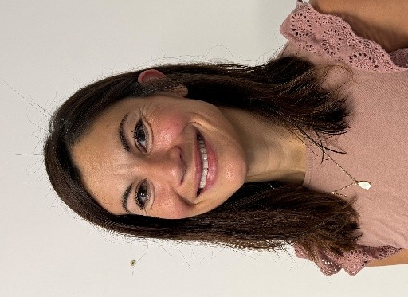
Mrs Masters Mrs Ruyant Miss Brown

What happens when I arrive at school?
When you come to school you will walk through the large green gate

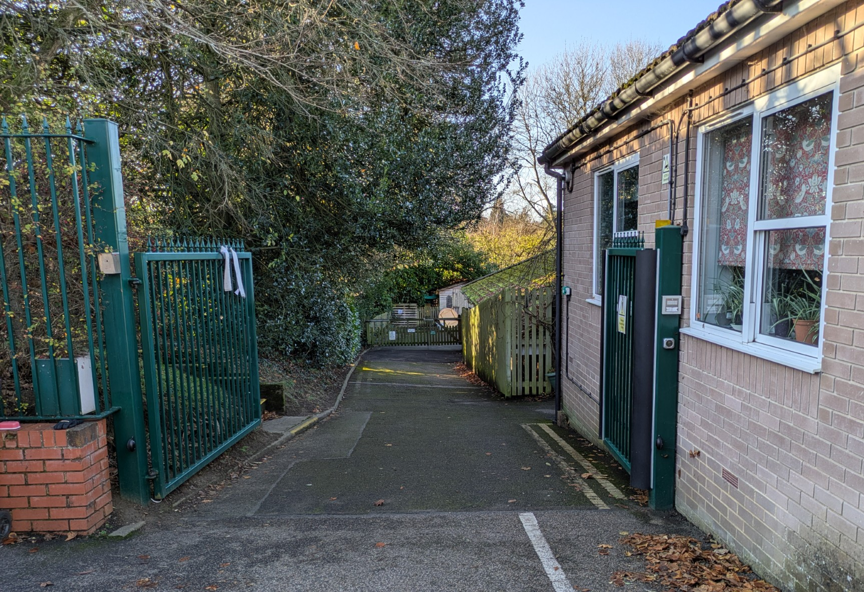

and walk round to the front door of the Early Years building.

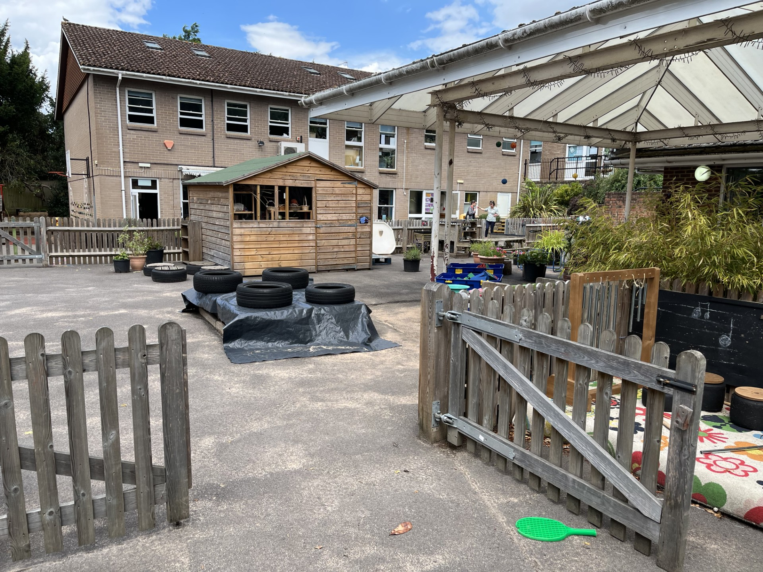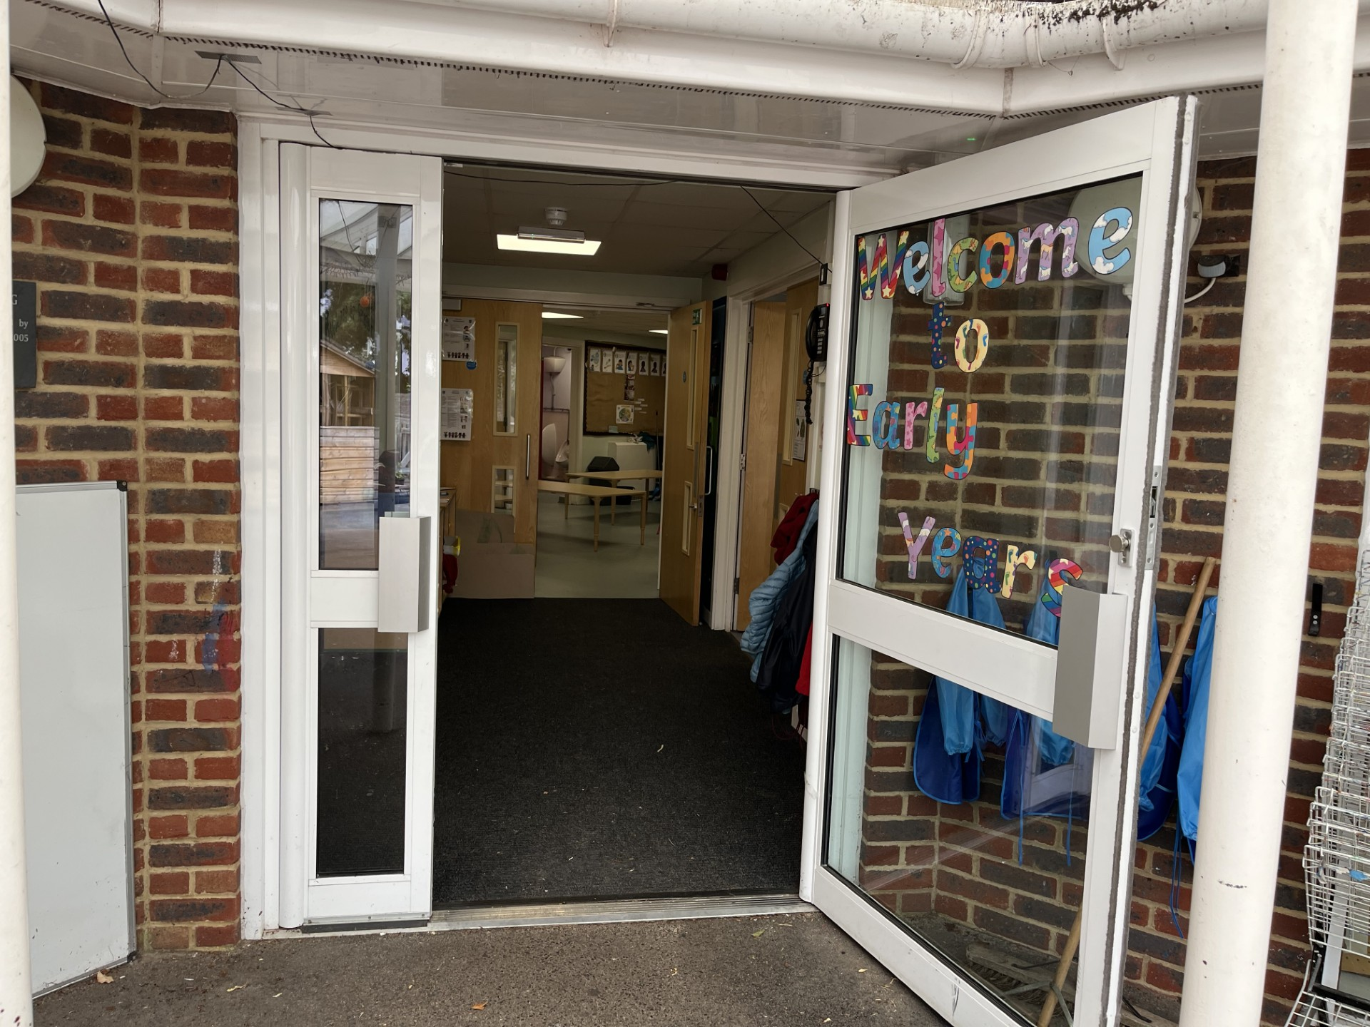

You will hang your coat up on your peg
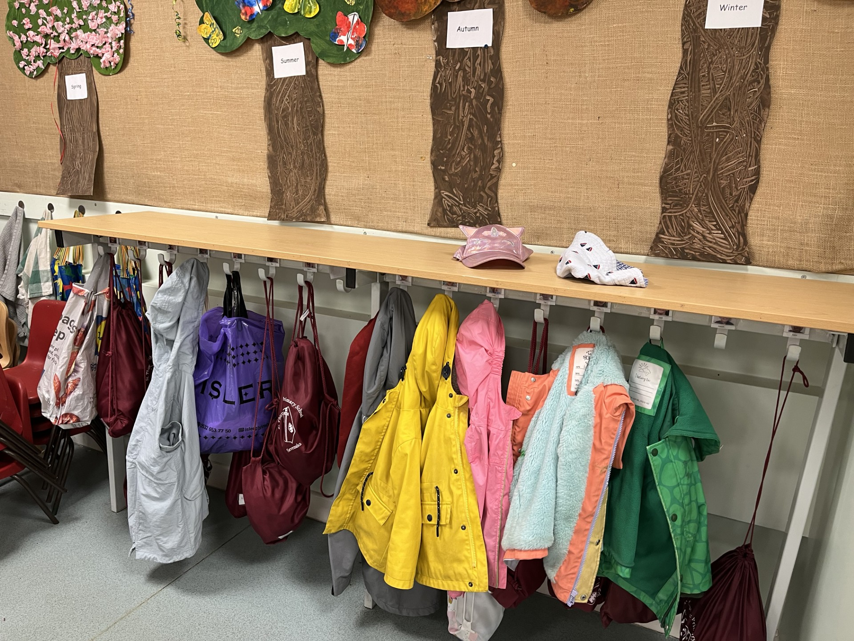

and come into nursery and find your name

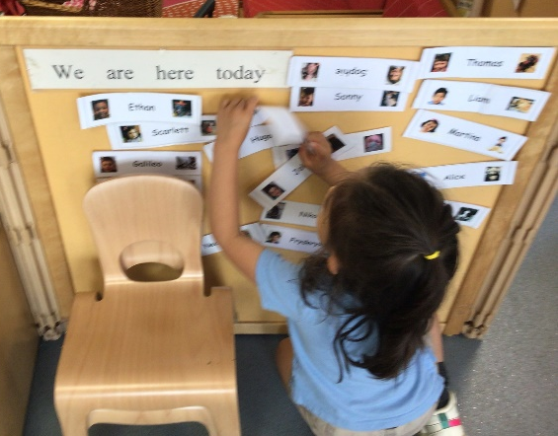

Going to the toilet.

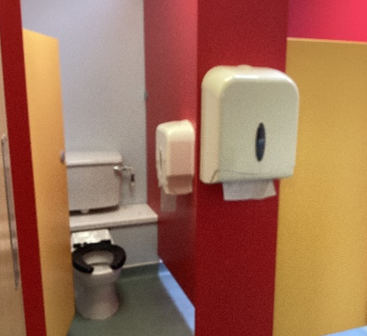

You can use the toilet whenever you need to, just tell one of the teachers. We are happy to take you if you need some help. Don’t worry if you have an accident, that sometimes happens when we are too busy having fun! It doesn’t matter at all, and we can help you change into clothes from your gym bag.
A typical day in Nursery looks like this:

Mornings
8:45am – Arrival
We hang up our coats and bags and go into the classroom, find our name labels and put them on the board. We look at books on the carpet while waiting for our friends to arrive.

9:00am – Register and prayer
We say good morning to everyone and we light the candle and say our morning prayer. We have a small circle time discussion about our weekly reflection theme.

9:15am – Physical activity outside
We go down to the big playground and play on the tricycles, scooters and use balls and hoops.

10:00am – Snack Time
We wash our hands and sit down at the tables in the green room for our snack.

10:30am – Group story time
We sit on the carpet and listen to our book of the week.

10.45am – Child initiated activities inside and outside alongside adult-led activities.
We select the resources we would like to explore inside and outside and work on activities with a teacher.

11.30 - Rhyme time/Sound of the week
We sing nursery rhymes, songs and poems and in later terms begin learning initial sounds as part of phase 1 phonics.

11.45am - End of morning session/home time
Morning children go home
We get ready for our lunch.

Afternoons

11.45pm – Lunchtime
We eat our packed lunches together in the green room.

12.15pm – Outside playtime

1.10pm – ‘Cuddly toy time’/quiet reading time
We lay down with a soft toy and listen to classical music and in later terms share books quietly with a friend.

1.30pm – Child initiated activities inside and outside alongside adult-led activities.
We select the resources we would like to explore inside and outside and work on activities with a teacher.

2.45pm - Group story time
We sit on the carpet and listen to a story.

3.15pm - Home time
Our parents and carers wait for us at the Nursery class entrance. Our teacher will make sure they see our grown-up before we can go (please let the school know if your child is being collected by someone else)
If we stay for After School Club, we are taken up by our teacher.
First Day of Nursery

The first day of nursery is an exciting milestone in your child's life. Your child is embarking on a journey that will lead them on many roads of discovery and learning. As wonderful as this new experience may be, it can also be quite daunting for a young child. New situations and change can, at times, be unsettling for all of us. For many children, this may be their first experience of separation from parents or care givers at home. It is common for even the most outgoing child to be anxious on the first day of nursery. Please know that the nursery staff are there to support and assist you and your child, to ensure their introduction to nursery is a happy and enjoyable experience.

Here are a few suggestions of things you can do as a parent to support your child:
• Prepare them for this new experience by explaining what to expect. Answer all questions directly and honestly.
• Convey a positive attitude. Young children are aware of your feelings and your enthusiasm will assure your child that nursery is a fun and exciting place.
• Establish a routine for both the night before they attend nursery as well as the morning preparation. Rituals and routines will add predictability and are comforting in unfamiliar situations.
• During the initial adjustment to nursery if your child needs to bring something from home such as a treasured blanket/comforter, cuddly toy or photo this is absolutely fine and can offer them reassurance.
• Clearly state to your child where you will be and when you will return. It may also be helpful to discuss what will happen when you are reunited.
• Maintain a clear good-bye routine. This may include warning your child you are leaving in 3 minutes, a kiss and hug, or a wave. Once you tell your child you are leaving, it is important to follow through. Extending the good-bye with, "Ok just one more kiss, and then I really have to go” tends to heighten anxiety rather than relieve it. Avoid sneaking away, as this seems to encourage children to become less trusting and makes the second day of School even harder.

Finally, please know that we are used to dealing with separation and understand it can be hard for the parents too! Please feel reassured that if your child is upset when you leave it shows you have a strong bond, and we will help them settle quickly. We are here to help make the first day of Nursery a happy transition and we look forward to an exciting and fun year.

Promises
Please read the following with your child and by doing so you agree to adhere to these principles.
Together we will
- Encourage everyone in our school family to do their best and show respect and love for others in accordance with our Mission Statement.
- Ensure that your child is valued for who he/she is and help them to achieve their full potential in their spiritual, moral, emotional and academic development.
- Demonstrate our Faith and our school’s foundation in the teachings of Jesus Christ, by what we teach and by example in the way we live and worship in our school.
- Strive to provide the best possible education we can for your child and create a safe, secure and stable environment in which your child can be nurtured both spiritually and academically.
- Be a welcoming school community and work in partnership with parents in the education of their children and encourage families to become involved in the daily life of the school.
- Keep you informed of your child’s progress through parents’ evenings and annual reports.
- Contact you if there is a problem with your child’s attendance or punctuality or behaviour.
Parents’ Promise
I will
As a parent I / we promise to:
- Support the aims of the school, its ethos and Mission Statement as detailed in the prospectus.
- Ensure that my/our child attends school regularly, punctually, suitably equipped and wearing the correct uniform.
- Avoid taking my/our child out of school during term time unless strictly necessary.
- Support the school’s policies and guidelines for behaviour.
- Encourage my child to show kindness, consideration and respect to other members of the school community.
- Accept the school’s ethos and give positive support to the teacher, acknowledging their professional views and skills.
- To park with consideration for our neighbours and safety of children at school.
Pupil’s Promise
I will
As a pupil I promise to:
- Come to school every day on time.
- Wear my uniform correctly at all times.
- Listen carefully to my teacher and do what I am asked by engaging in my learning.
- Try hard in class to engage in my own learning.
- Be kind, honest and polite to others.
- Observe all school rules and treat everyone with respect.
- Talk to an adult if I am unhappy or worried about anything, or if I need help.

ST THOMAS’ CATHOLIC PRIMARY SCHOOL
Learning in the Light of Christ

