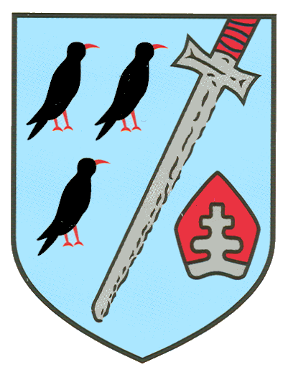

Welcome to
St Thomas’
A Guide for Families in Y3
Address
South Park
Sevenoaks, TN13 1EH

Phone
01732 453921

Website
http://www.saintthomas.co.uk

Email
office@st-thomas-sevenoaks.kcsp.org.uk
nursery@st-thomas-sevenoaks.kcsp.org.uk

Dear Family,
We warmly welcome you to St Thomas’ Catholic Primary School part of Kent Catholic Schools Partnership. This booklet is designed to introduce you to the school and help you to feel right at home!
Our Mission
As a Catholic school, we work with the whole community to promote the well-being of every child and family. From this secure foundation, we nurture every child’s development as a learner to become a skilled and creative individual who is able to make a positive contribution to society. At St Thomas’, everything we do is guided by the following school mission:

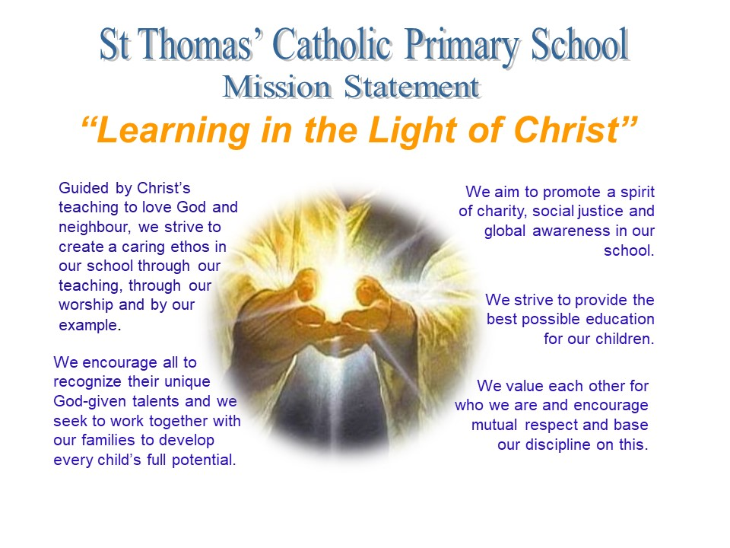
We are a Catholic School
The Catholic life of the school is rich in opportunities for children to encounter God and to deepen their relationship with Him as a loving, compassionate Father. Through prayer, liturgy, Religious Education lessons, and the relationships and support for each other we enable children to come to know and love God. Prayer is central to the daily life of our school.
In this way we aim to help the children to come to value and respect the power of prayer and its place in their relationship with God. The key events of the liturgical year are celebrated in many forms such as whole school Masses, Christmas Carol Services, Nativity performances, Lenten devotions including Reconciliation, Passion play, feast day celebrations, the Rosary.

Y3 Class
Welcome to Year 3

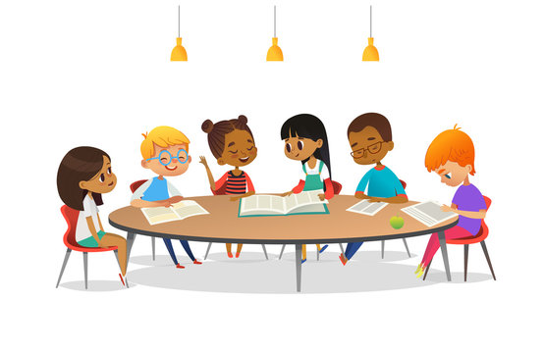

Mrs Busvine – class teacher  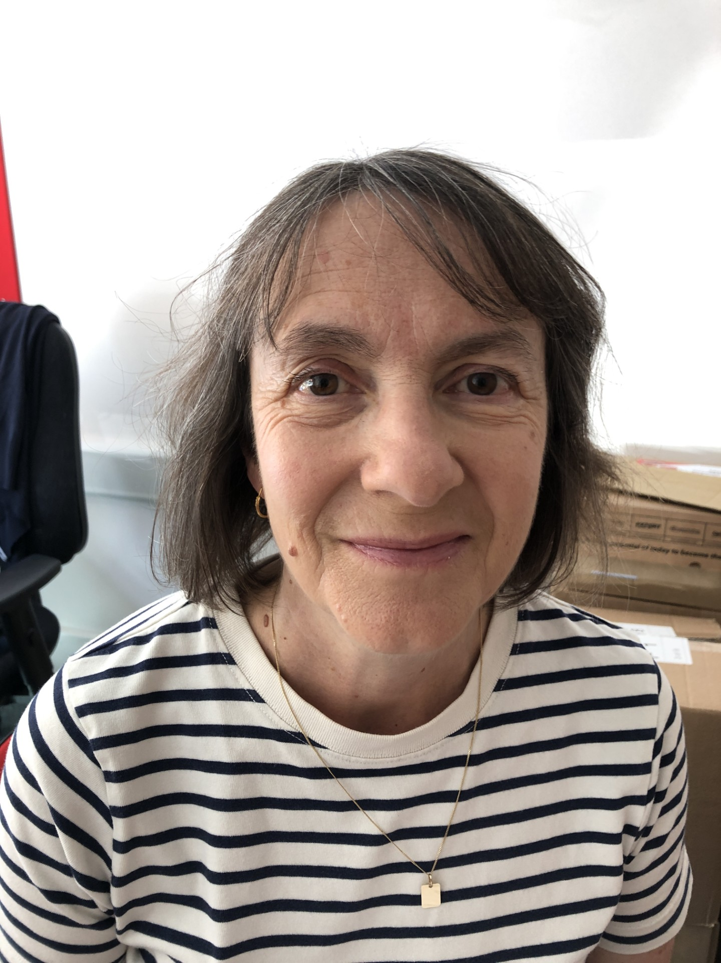  Hello, my name is Mrs Busvine. I will be the teacher on Mondays, Tuesdays and Wednesdays. I love books and reading I am really looking forward to being your teacher next year. | Mrs Carlton –teaching assistant  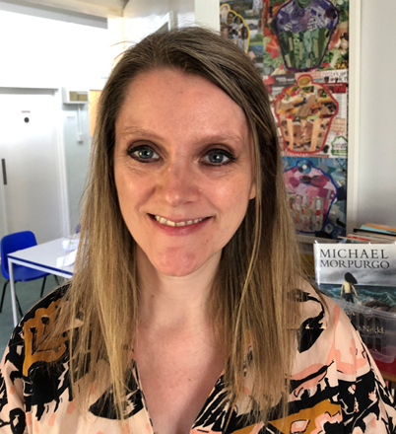  Hello, my name is Mrs Carlton. I will be the teacher on Wednesdays and Thursday. I am also the music teacher so we will have lots of fun composing and performing music.
What happens when I arrive at school?  8.30am - Arrival  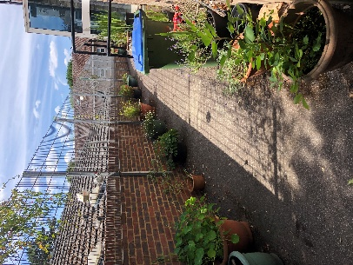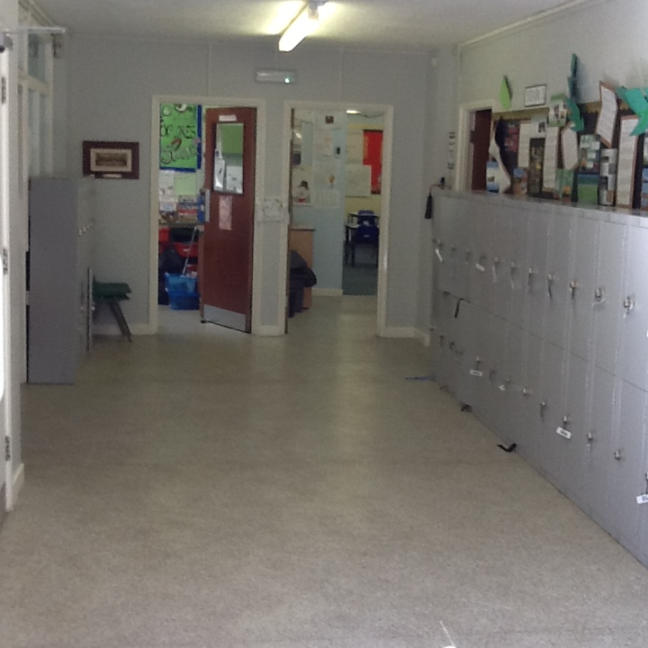  You will come into school along the terrace and put your things in your locker. Your classroom door is on the right next to the library.  You can use the toilets next to the terrace door.  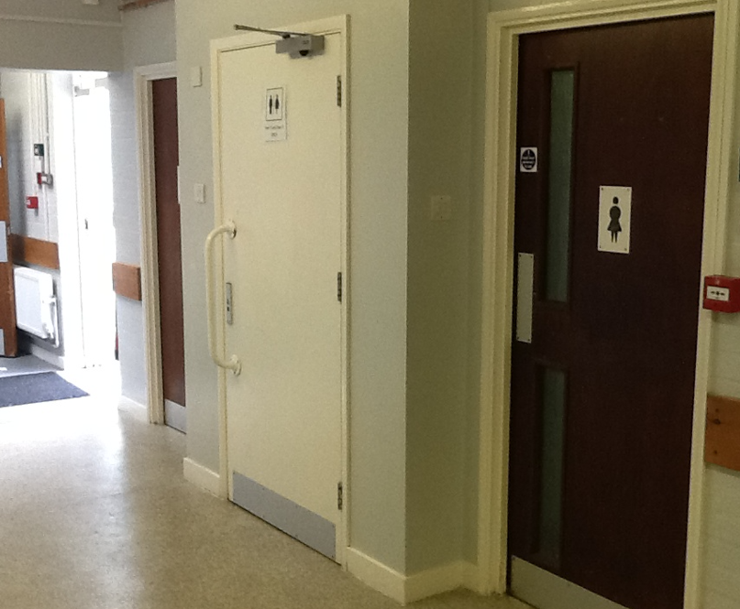 | We say our morning prayers, have quiet reflection time and listen to a poem.  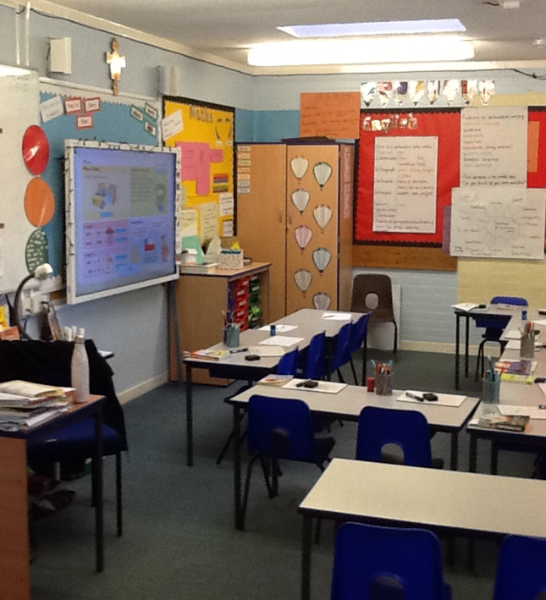  8.50am – Register & Morning Prayers

Here are some pictures of your new classroom. It is next to the school library and the Year 5 classroom.
Our playtime is 10:30 to 10:45. Our lunchtime is 12:10 to 1:10. We go out at the start of our lunch break and then we are called in from the playground to go into the hall to eat.

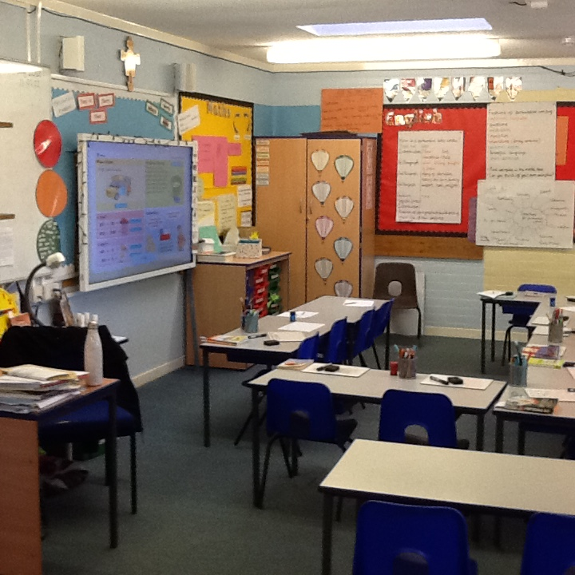 | 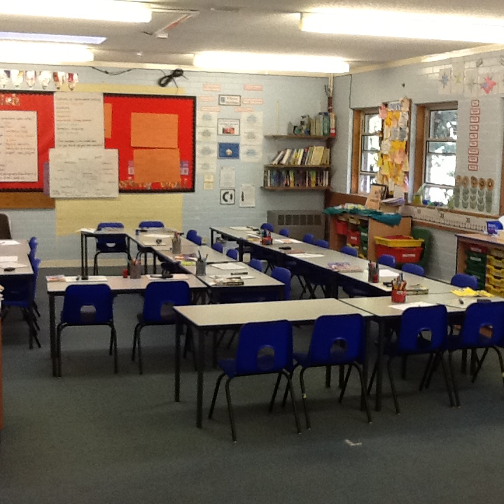 | 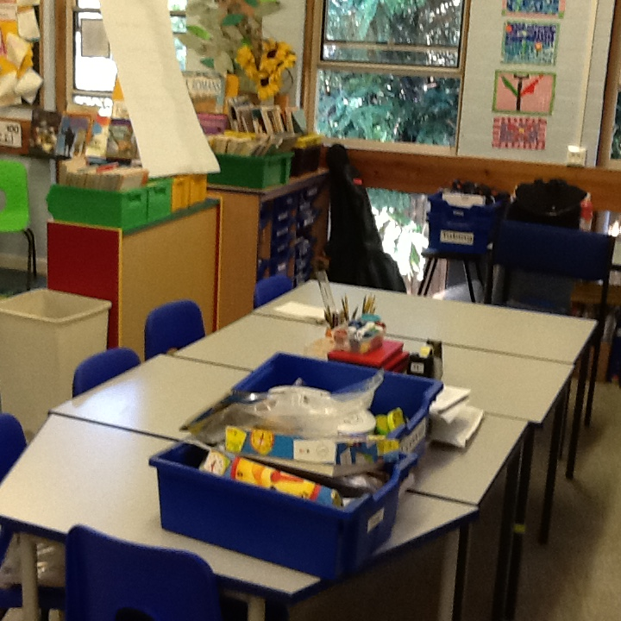

During Term 1 in Year 3

For our history work we will be learning about
the Stone Age.

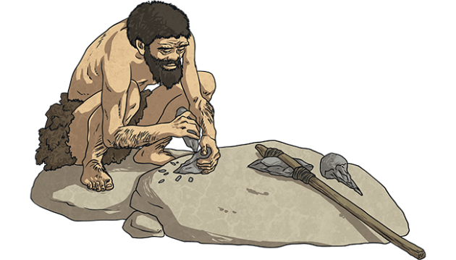

For our Science work we will be learning about rocks and soils.

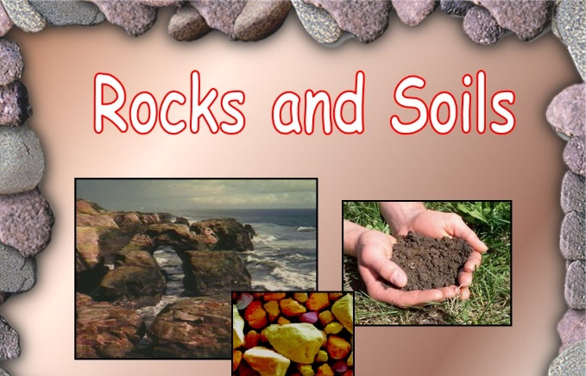

In our English work, we will be enjoying a range of journey stories.
Reading
These are some books you might like your parents to read to you over the summer holidays. The Magic Faraway Tree by Enid Blyton, Pippi Longstocking by Astrid Lindgren, The Borrowers by Mary Norton, Charlotte’s Webb by E B White, Jumanji by Chris Van Allsbury
Some things to do before September …

- Take part in the reading challenge from the library. Enjoy reading and listening to a range of books.
- Listen to a story read by a parent every day.
- Practise counting in 4s, 8s and 50s and 100s.
- Find 10 or 100 more or less than a given number.

Staff
Ms Leahy  Headteacher |  | Mrs O’Keefe  Secretary and Admissions
Mrs Motta  Finance Officer |  | Mrs Bosworth  Nursery Administration & Extended School
Teacher |  | Teaching Assistant
Miss Allen & Mrs Tan  Nursery |  | Mrs Ruyant  Mrs Masters  Miss Brown
Miss O’Keefe  Year R Class Teacher |  | Mrs Driver  Mrs Couldwell
Mrs Bourke and Mrs Dewell  Y1 Class Teachers |  | Mrs Yule  Mrs Ahern
Mrs O’Keefe Parr and Mrs Donoghue  Y2 Class Teachers |  | Mrs Betts
Mrs Busvine and Mrs Carlton  Y3 Class Teacher |  | Mrs Way
Miss Tsang  Y4 Class Teacher |  | Mrs Roberts
Mrs Fromings and Miss Serratosa-Rojas  Y5 Class Teacher |  | Mrs Brennan
Mrs Williams  Y6 Class Teacher |  | Miss Serratosa-Rojas
Mrs Carlton
Music Teacher
Mrs Stevens, Mrs Perry  Mrs Debie, Mrs Lucken, Miss Brown  Extended Care |  | Mrs Eastwood  Lunchtime Supervisor  Extended Care

How We Communicate with You
Website
The address is http://www.saintthomas.co.uk where you will find a great deal of information including curriculum, policies, important dates, newsletters and blog. Please check the class pages on the website for any news from the class teacher. Please use the calendar on the website for forthcoming events.

Parentpay
ParentPay is a secure online payment system that replaces cash payments for school meals, trips, events and activities in our school and nursery. ParentPay is easy to use, secure and protects your details.
Signing up for ParentPay: if you have supplied your email address to the school an email will automatically be sent to you with a link and password to login to the system.
Through ParentPay you will receive:
- Newsletters
- School trips information
- Clubs information (excluding After School Club and Breakfast Club)
- Class newsletters
- Parents’ Evening information
- Girls’ summer dresses purchasing instruction
Weekly Newsletters (via ParentPay)
- Teacher’s newsletter. This is filled with photographs of the children’s learning. The email will contain a Microsoft Sway link to access the content.
- The second comes from the Headteacher and contains news about our recent events and important dates for your diary, including term dates. These newsletters will also be available on the school website and in hard copy in the noticeboard by the school gate.
- Please also check the board outside the school gate for any last minute arrangements or reminders.

Please provide the school with your correct email address and mobile telephone number. We use email to send the newsletter and other information, and we use ‘Texts’ to send urgent messages (we promise not to flood your inbox!).

The School Day
The school gate opens at 8.30am. Children should enter the gate at the latest at 8.45am, to ensure they are on time to begin lessons at 8:50am. Any child arriving late should enter the school by the office and make sure the office staff are made aware of their arrival. We ask parents to make every effort to ensure their child is in school on time as being late is disruptive to the late child, teacher and other pupils.

Lunchtime is at 12 noon for nursery, reception and Y1, 12.10pm for Y2/3/4/5/6. All lunches should be booked via ParentPay. This ensures that the kitchen know the correct number of children to cater for. ParentPay is used to pay for school meals in KS2.

The school day ends at 3.15pm. Please ensure that children are collected promptly as it can be very upsetting for them to be ‘left behind’. If, in exceptional circumstances, you are running late to pick up your child, please call the office as soon as possible to let us know. If you have not arrived by 3.30pm your child will attend After School Club and a charge will be added to your Parent Pay account. Unless they are in Year 6 and have written parental permission, children are required to be collected by a responsible adult. If your child is to be collected by someone other than their main carer, please let the school know in advance, otherwise we will not be able to release them.

Wrap-Around Care (Extended School)
The school offers a Breakfast Club and an After School Club. With the extended hours, the school day starts at 07:30 until 18:00. Should you wish to book your child into Breakfast Club or After School Club please email: extendedschool@st-thomas-sevenoaks.kcsp.org.uk
Breakfast Club runs from 07:30 to 08:30. Pupils get ready to go to class at 08:15 so please ensure your child arrives in plenty of time to eat their breakfast.
After School Club runs until 18:00. Please be on time to collect your child.

Both Breakfast Club and After School Club are attended by all year groups, so that children from YN to Y6 will have the opportunity to be together whilst the activities will cater for different learning stages and interests. Collaboration between older and younger children is actively encouraged as it is important to our school that children are respectful and kind to each other across all age groups.

Physical Education
Your child’s class letter will contain details of which days they have PE lessons. During the year, KS2 pupils will attend an off-site PE lesson for Swimming. Please note parents need to pay for the swimming lessons. Class letters will advise about requirements for swimming and more information.

Healthy Eating
School Meals
The school provides lunch for YR to Y6 children which needs to be pre-booked on ParentPay. Rest assured that all children will have lunch even if there are issues with ParentPay booking or simple oversight. School meals are free to pupils in Reception and KS1. For KS2 pupils the cost is £3.15 and must be booked and paid for prior to the day of requesting a meal. This is paid through the online ParentPay system. Menus can be found on the school website.

Packed lunches
A few parents choose to provide a packed lunch for their children. We ask that packed lunches follow the same guidelines as for snacks. Remember to send your child’s lunch in a washable, reusable container.
Please note that YN children who are staying for a full day will need to be provided with a sesame and nut free packed lunch which they eat with their class in the EYFS block.

Snacks
We ask parents in YR to Y6 to support our healthy eating policy by providing a healthy snack for pupils at morning snack time. Snacks should be provided in a washable, reusable container clearly labelled with your child’s name.

As well as the free piece of fruit or vegetable, the Nursery provides an additional snack and parents are requested for a voluntary contribution.

The school regularly provides guidance on health snacks. Here are some snack dos and don’ts.

Dos | Don’ts
- A piece of cheese (not highly processed e.g. cheese strings, dairy lea, babybel). | - Nuts. (including marzipan, Nutella & peanut butter) - We have a number of children in school who are severely allergic to nuts and, unless we ban nuts altogether, we cannot guarantee their safety. Please support us to keep our school a SESAME & NUT FREE environment.
- Oat cake, cracker, rice cake, pitta bread, breadsticks, a sandwich, a small bread roll or a bagel. | - Chocolate and sweets. Occasional chocolates at home are lovely. At school they are messy and not the best choice for providing long term energy. Sweets are not appropriate snacks at school.
- Nut-free cereal bar or other non-chocolate bar. Please note some cereal bars have more sugar than others. | - Fried food including crisps. We appreciate that some crisps are not fried, but we prefer children not to eat crisps as a snack as we are not able to monitor what they are eating.
- Dried fruit (raisins, apricots etc).  - A handful of popcorn (preferably homemade with minimal salt or sugar not from a microwave bag). You do not need to provide a whole bag. A handful is sufficient | - Too much salt or sugar. In line with the school’s healthy eating policy, please choose snacks that keep your children going for longer and benefit their long term physical and dental health.

Drinks. Please make sure that your child brings in a water bottle to school everyday. Bottles should go home each day for washing.

The school actively promotes good personal hygiene e.g. washing hands whenever required (especially before and after meals) and using a tissue when coughing or sneezing. As part of the YN curriculum, the children are required to brush their teeth after they have eaten their lunch. Parents/carers will need to provide their child with a toothbrush to use in school.

School Car Park
The school car park is for use by members of staff only. As the car park is in constant use, please help us keep you and your child safe by using the pedestrian walkway at the beginning and end of the day. If you travel to school by car, please either park on a designated parking space on the road or in South Park Car Park. Please be mindful of our road layout and parking regulations. Selfish parking puts other children’s lives at risk.

What to do if your child is sick
Please call the school by 9:15am if you have decided to keep your child off school due to illness.
We ask that you carefully consider whether keeping your child off school is the best solution, as any absence will be detrimental to their education. Colds and other minor illnesses are not reasons to stay at home. However, if your child has had diarrhoea or has been sick, they must be symptom free for at least 48 hours before returning to school. Your co-operation in helping prevent the spread of infectious illnesses throughout the school is appreciated.
If a child becomes sick in school, for example they develop a temperature or vomit, we will call you. It is important, therefore, that we have up-to-date contact numbers.
Medicine: We do not routinely administer medicine to children in school, so please speak to the office staff if you think your child needs to be given medicine during the school day.
Leave of Absence
No leave of absence for holiday during term time will be authorised. The exception is for parents who can only take holidays in term-time, or when a family needs to spend time together to support each other during or after a family crisis e.g. bereavement. Such requests need to be made in writing to the Headteacher, detailing in full the reason for the request.

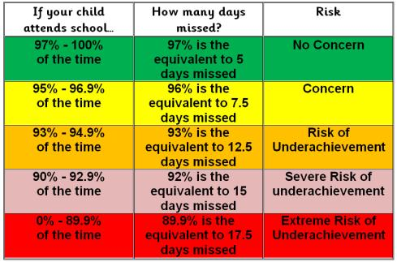

School Uniform
Details of our school uniform are below and can be found on our website. Uniform can be bought at Horncastles on Sevenoaks High Street or through their website www.horncastles.co.uk. Girls’ summer dresses need to be purchased through the school office. Look out for notifications about when and how to purchase.
Good quality second-hand uniform is also available during occasional sales on the playground.

Please make sure all items are clearly named. This can prevent a child becoming upset if things go missing and saves a great deal of our time!
Plain, stud earrings may be worn and a simple chain with a cross (these will need to be removed for P.E. including swimming).
Please ensure that you child has the appropriate shoes and clothes for outdoor play, whatever the weather.
Children might be asked to leave a pair of wellies at school, as well as a named gym bag for spare clothes (see below, section ‘School Bags and Snack Bags’)
On P.E. days, children need to come to school wearing their P.E. kit consisting of school shorts, navy joggers, a navy school t-shirt and black or dark coloured trainers (with Velcro for the younger classes). Some P.E. is done barefoot.

Winter  From: Beginning Autumn Term 2 (After October half term) To: end of Spring Term 2 (before the Easter Holidays) | Summer  From: Beginning Summer Term 1 (After Easter Holiday) To: End of Autumn Term 1 (Until October half term)
ALL UNIFORM MUST BE NAMED OR WE WILL BE UNABLE TO RETURN ANY ‘LOST’ ITEMS.
Year 3, 4, 5 & 6 | Year 3, 4, 5 & 6
- Grey skirt, pinafore or trousers  - Pale blue long sleeve school shirt  - School tie  - Maroon sweatshirt (Horncastles)  - Navy or grey socks or tights  - School fleece - optional (Horncastles)  - Navy or black warm, waterproof coat  - Black shoes – not trainer type | - Summer dress (school office), grey shorts  - Pale blue short sleeve school shirt (with tie)  - Pale blue short sleeve polo shirt (no tie)  - Short navy ankle socks  - Maroon sweatshirt (Horncastles)  - Navy or black lightweight waterproof coat  - Black shoes – not trainer type  - Sunhat with a brim is advisable
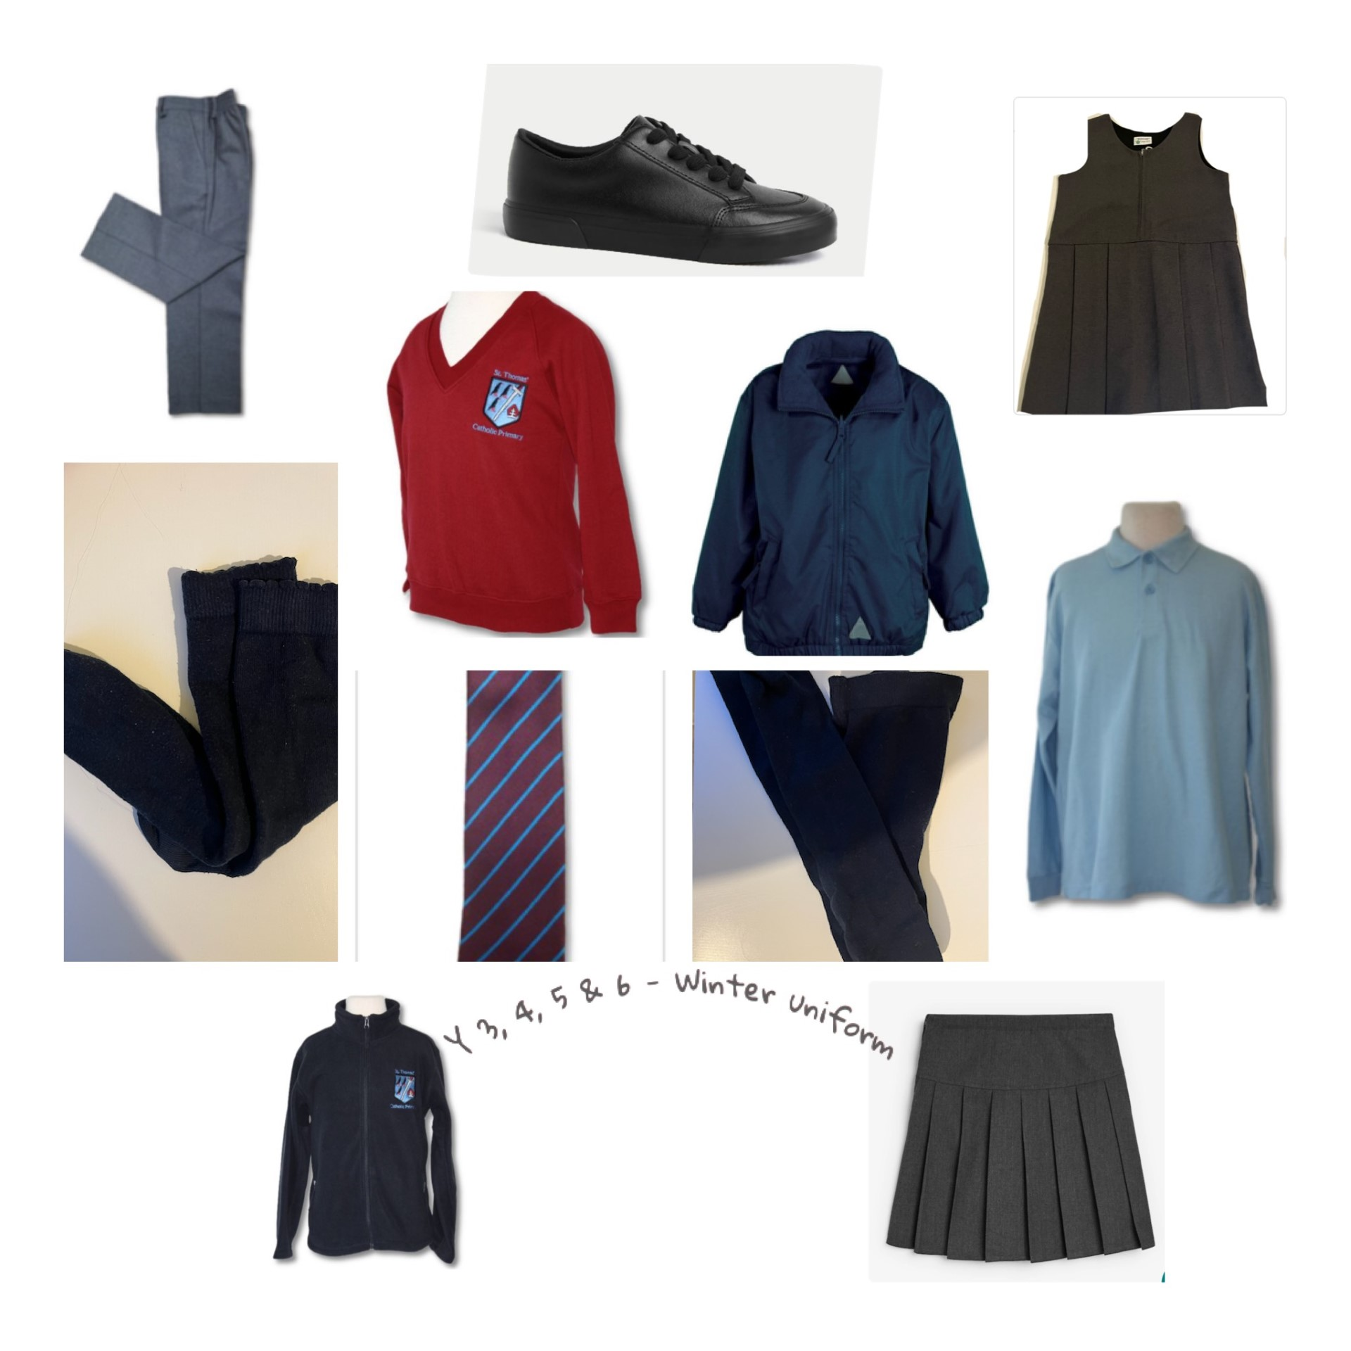 | 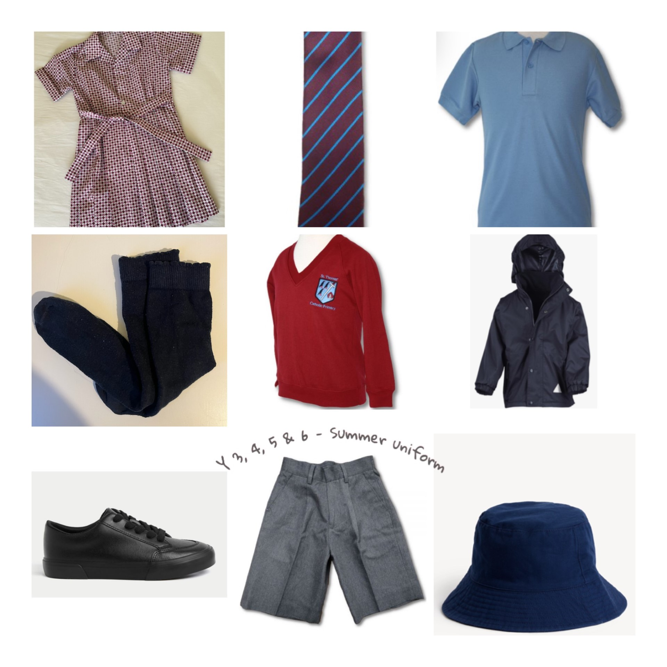
P.E. Kit for all ages
- Maroon P.E. shorts  - Navy blue jogging bottoms  - School Navy P.E. t-shirt  - Trainers (with Velcro for the younger classes) | 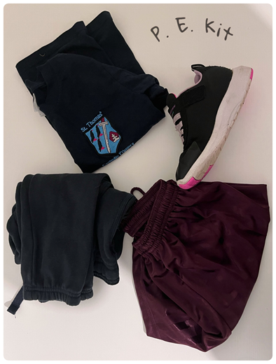

School Bags and Snack Bags

Pupils will need bags to carry their books, snacks and water bottles. Some children may need to leave a bag with spare clothes at school.
Children in YR and Y1 will need a bookbag to carry their book in. You may wish to attach a keyring to the handle to help your child identify their own book bag. Please limit this to one keyring.
School book bags, rucksacks and gym bags (for spare clothes) can be bought from Horncastles.

 | Small Rucksack  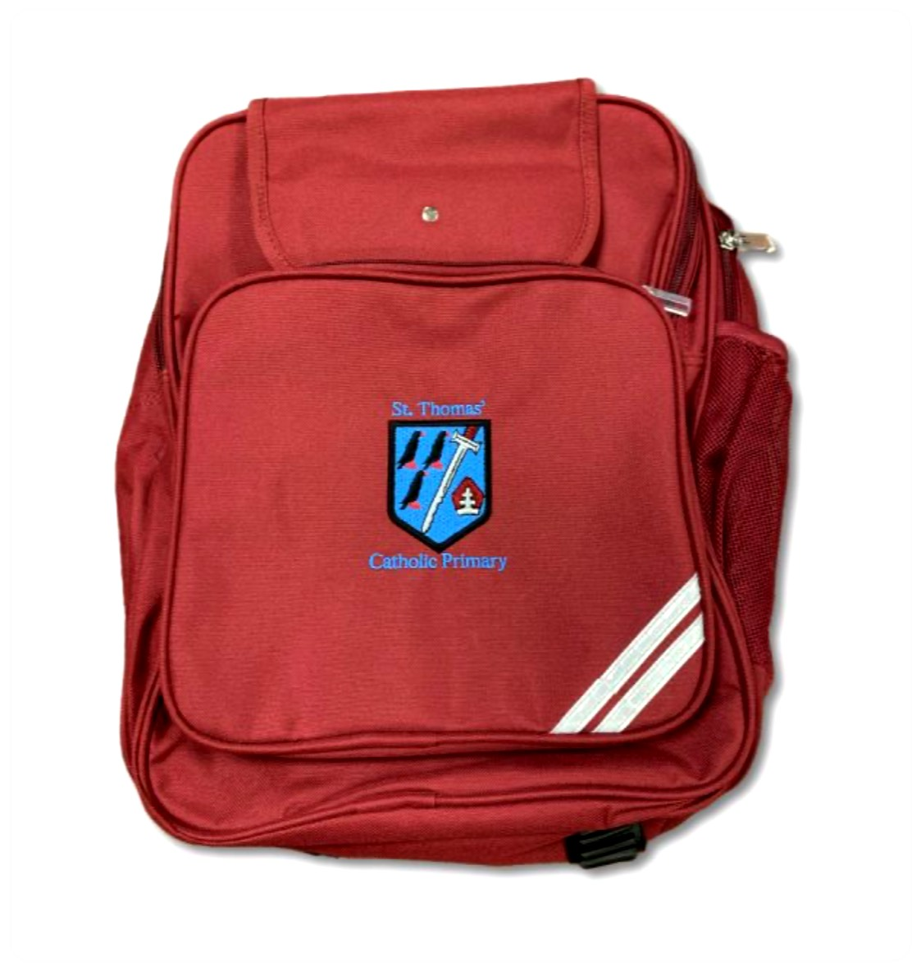 | Snack-Box  (any) | Gym-bag  (spare clothes)  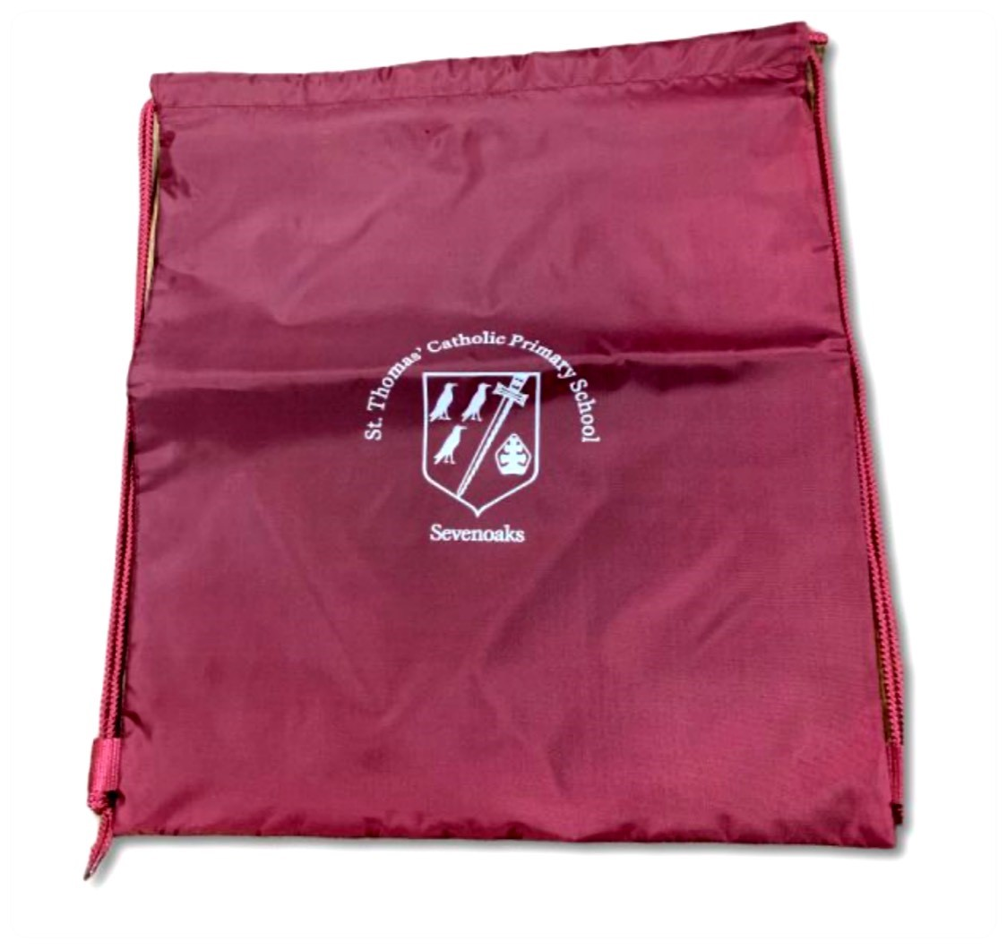
Y N | ✅ | ✅ | ✅
Y R & Y 1 | ✅ | ✅ | ✅
Y 2, 3, 4, 5 & 6 | ✅ | ✅ | ✅

Behaviour and House Token System
Pupils are assigned to a ‘House’ at St Thomas’. These are named after four saints:
 | 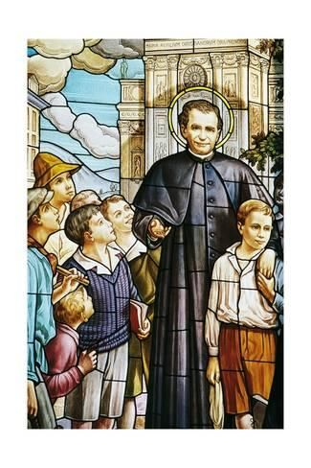 | 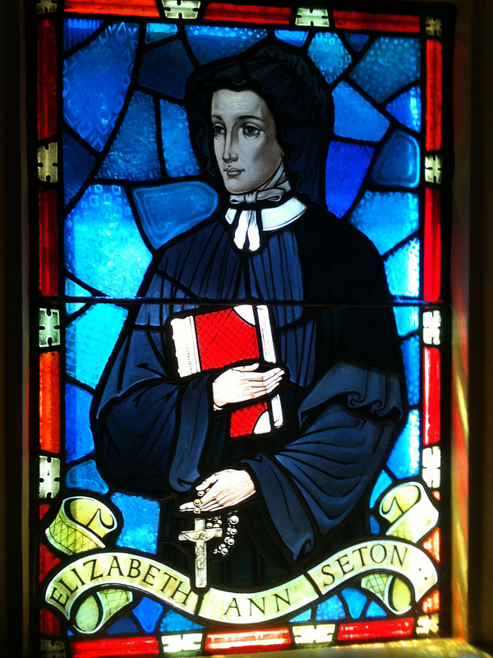 | 
Porres House  (St Martin de Porres, Ruby) | Bosco House  (St John Bosco, Topaz) | Seton House  (St Elizabeth Seton, Sapphire) | Cabrini House  (St Frances Cabrini, Emerald)

Pupils can earn tokens for their House when staff observe them following rules or doing a kind deed. Siblings are allocated to the same house. Houses are used at Sports’ day and during other projects when children are grouped across the school to work with children of other ages in a spirit of co-operation and support.

There is an assembly each week to celebrate the school virtues and the Virtues to Live by. Merit certificates will be awarded to reflect school virtues. Certificates are awarded to individuals who have made a special effort and the weekly house points total is announced.

Pupil Voice
Each class (Y1 – Y6) elects two School Council representatives, who attend School Council meetings and present the views and suggestions of their class. Hustings are usually held before the election and the process is taken very seriously. Our School Council meets regularly to give their views on and help make decisions about all aspects of school life. A Chair, Vice-Chair and Secretary are elected within the group (usually from the older years) and they run the meeting themselves (supported by a member of the Senior Leadership Team). Minutes are distributed back to classes. Children who have been on School Council must wait a year before standing again.

Parent Voice and Getting Involved
Parents and teachers
Parents are encouraged to have regular contact with their child’s class teacher. In the afternoon staff accompany their class to the playground and you are welcome to speak to the teacher on an informal basis there. If required, appointments can be made at a mutually convenient time with any member of staff, who can be contacted via the school office.

Help us to improve
We regularly ask for feedback through surveys which are accessible through the school website, and a link to them will be sent out via email.

Meet the Governing Body
The role of Members of the Governing Body is to support the school, being prepared to account for the school’s overall performance. Members also act as ‘critical friends’, which means offering constructive advice, a sounding board for ideas, a second opinion on proposals and help where needed. Members are there to set the school’s ethos and strategic direction. They are also expected to hold the Headteacher to account for the performance of staff and children, and to ensure that public money is being well spent.

Parent Teacher Association
Parents are automatically members of the Parent Teacher Association (PTA). Please do attend meetings to see how you can help out with fundraising and supporting the school.

Parental Support
We welcome parental support at school. If you have any free time, please let your child’s class teacher know and we can make suitable arrangements, which may not necessarily be in your child's class. You will be asked to complete a police check (DBS) form.

Curriculum
At St Thomas’, we follow the Early Years Foundation Stage (EYFS) Curriculum in Nursery and Reception and the National Curriculum in Key Stage 1 (Years 1 and 2) and Key Stage 2 (Years 3-6).

We structure our curriculum in all years through a ‘creative curriculum’. This means that we select a main topic and teach all subjects in the context of that topic. We often select topics based upon the enthusiasms and interests of the children themselves.
Every half term (6 weeks) teachers will send parents a ‘topic map’ detailing the planned learning for the topic.

Every 6 weeks, children’s progress is discussed and tracked by the Senior Leadership Team (SLT) in conjunction with the class teacher.

Special Educational Needs
All children are different, and teachers differentiate each lesson to cater to all learning styles and needs in their class. Some children may be identified by the school as having ‘Special Educational Needs’. The school supports all pupils in the following way:
- In the second week of each term the Headteacher and SENCO meet with all class teachers to discuss the progress of all children. Class provision plans are then written to ensure that all necessary support is put in place, assessed and reviewed.
- This review meeting will lead to children being assessed by the SENCO team in the classroom.
- If necessary the school will send home a school concern form. This may lead for further assessment of a child’s needs. Some children then have an individual provision plan, others go on to be supported with an Education Health Care Plan, depending on need.
- Parents sometimes seek assessment of their children from other agencies. The results of these assessments will be discussed at the termly meeting. A meeting between the SENCO team and parents will then be arranged.
- Parents of all children who have an individual provision plan will meet with the class teacher (either in person or on zoom) three times a year to discuss their child’s needs.
The school employs a SALT (speech and language therapist) and an OT (occupational therapist) directly so that we are able to support our children as quickly as possible.
If you have any queries please email the Headteacher or the SENCO or make an appointment to meet your child’s teacher at a mutually convenient time.
Homework
At St Thomas’ we try to balance the pupil’s need to be a child at home and to have ‘time off’ with our responsibility to prepare them for secondary school. Children are given homework as follows:

EYFS | - 10 minutes per day reading with a parent.  - Record items onto online learning journal once a week.  - Occasional topic homework.
Years 1/2 | - Reading with a parent, daily.  - Times tables / Number bonds should be practised on an on-going basis.  - 20 minutes weekly maths activity.
Years 3/4/5/6 | - Reading every day, both school reading books and free choice books.  - Weekly times tables practice is expected until the child has learnt all times tables.  - 20 minutes weekly maths activity.  - Occasional Topic work – children can be given a topic to research and then present in class (teachers will make sure that this doesn’t have to be done only over holidays).
Look out on the SWAY newsletter from the teachers to find out about homework each week.

Prayer and Liturgy and Performances
Each class leads a Collective Worship once a term to share the Sunday’s gospel with the whole school. Parents of that class are invited to attend. These are usually on a Friday at 9.00am. Dates are published on the newsletter. We also hold a number of masses, special performances, church services and concerts throughout the year. The details of these will appear in the newsletter. Look out for our Harvest Festival, Christmas Carol Service, Nativity and Music Concert.

Trips and Residential Visits
St Thomas’ is committed to providing a creative and varied curriculum for your child(ren). We regularly take the children out of school to learn in different environments, making use of the many wonderful local facilities. We ask parents to complete online consent form when their child starts at St Thomas’, which covers us for all day trips. We will always let you know well in advance of any day trips so that you know your child will be going off-site, and what they will need to bring. We will sometimes ask for a voluntary contribution towards a trip.

We are very fortunate that the PTA provides some funding towards the cost of these trips.

During your child’s time at St Thomas’ they will enjoy two residential trips. In Year 5, pupils spend one night at Bowles, an inspirational residential development centre in the stunning location on the Sussex-Kent border near Tunbridge Wells. In year 6, pupils visit a residential centre, spending five nights pursuing outdoor activities such as kayaking, surfing, coasteering and many others. We aim to keep costs as low as possible, but we recognise they can be a significant outlay for parents. For this reason, parents are welcome to begin contributing towards a ‘residential trips fund’ for their child as early as you wish. Parents wishing to start paying towards the school residential trips should contact the school office for more information.

Frequently Asked Questions

Can children bring personal property in school (including pencil cases, playing cards, phones, toys, games)? | No – personal items will be put in a safe place by staff and returned to parents (not children) at the next possible opportunity. The school cannot take responsibility for loss or damage to any personal property.
How do we communicate with parents | Weekly newsletter from the Headteacher. Weekly SWAY newsletter showcasing the children at school that week.  Termly class newsletter – emailed directly to parents and also available on the website.  Class WhatsApp group. Parents set up WhatsApp groups and class reps are appointed. This is likely to take place shortly before the beginning of the next school year, or during the first week of the school year.
How do we get access to the newsletters and other emails? | By signing up to ParentPay.
How do we pay for school meals, clubs etc? | Via ParentPay
How do we sign up to ParentPay? | Please provide the school office with your designated email address. Only the parent signed up with ParentPay will receive the newsletter, so if both parents wish to receive the newsletter directly, they will have to both register with ParentPay. Alternatively, they can set up an auto-forwarding rule in their inbox.
Are mobile phones permitted in school? | Mobile phones are not permitted in school. If there are exceptional circumstances, please make an application to the Headteacher explaining why it is necessary. Year 6 pupils are allowed to walk home alone with written parental consent, in which case mobile phones may be brought in. Year 6 parents should write a note to the office notifying that their child will be bringing in a mobile phone. These phones should be handed into the Y6 teacher in the morning and collected at home time.
Can pupils bring money to school? | Money should not be brought into school unless requested for something specific and must always be contained in a clearly named purse or envelope.
Where do we hand in forms and letters? | All letters or forms, whether for the class teacher or the school office, should be handed in by your child to their class teacher at morning registration, not taken to the school office. To support our efforts to be more environmentally friendly, please only send notes, letters or forms in an envelope if it contains a cheque, money or confidential information.  Most correspondence is sent home via our email system. If you are unable to print any forms sent to you electronically, please collect a copy from the school office.
Can we celebrate birthdays at school and bring cakes/party bags? | We love to celebrate birthdays at school and welcome birthday treats, however there are a few rules:  - Muffins, cupcakes, fairy cakes, haribo and biscuits are the best option if you want to send in a treat for the class to share (as they don’t need to be cut up).  - For all of the above, if it has nuts or traces of nuts, we cannot accept it in school. Please also take into account any other allergies within the class e.g. dairy free.
How can we speak to teachers when the child has an issue? | Arrangements can be made at pick up and drop off, and the office can facilitate individual meetings. Please let us know if you have any concerns about your child, as we would rather know as soon as possible.
Does the sunhat need to be from Horncastles? | No, any sun hat would do.
When are the teachers/parents evening? | These are usually during Term 2 and Term 4. Dates will be announced in the newsletter via ParentPay. The newsletter will contain a link to the available 10-minutes slots that will be booked online.
Do children attend teachers/parents evening? | Yes, it is encouraged.
We lost our belongings. Who can we contact? | Named items will be returned to the relevant pupil. Any unnamed lost property can be reported to the school office. We do not have a ‘lost property’ box. Lost snack boxes can be found at the school gates. Clothing is left outside the Headteacher’s Office where children can look during the day. Any unclaimed items will be hung from the school gate for parents to check at pick-up and drop-off.
With snow, will the school be open? | It depends – we will make every effort to update the website first thing to let parents know if the school will be open or not.
What will pupils do during Breakfast and Afternoon club? | The pupils will be involved in age-appropriate games and activities. Please speak to a member of staff for details.

Above all…
Your child’s experience at school should be a happy and successful one. Please let us know if you have any concerns about your child. We would rather know as soon as possible if your child is having any difficulties, so speak to the class teacher as soon as you can. All staff are available by mutual appointment which can be made through the office.
Please see below the promises we make.

Child Protection
We place a high priority on child protection. Our Child Protection Policy includes the training of staff to recognise and prevent abuse, empowering children to avoid and report abuse, and supporting children who may have been abused. The school has a statutory duty to act on all disclosures of abuse and will always follow the Local Authority child protection procedures whenever a concern is raised. Wherever possible we will try to keep parents informed at all stages of our procedures.

Promises
Please read the following with your child and by doing so you agree to adhere to these principles.

Together we will
- Encourage everyone in our school family to do their best and show respect and love for others in accordance with our Mission Statement.
- Ensure that your child is valued for who he/she is and help them to achieve their full potential in their spiritual, moral, emotional and academic development.
- Demonstrate our Faith and our school’s foundation in the teachings of Jesus Christ, by what we teach and by example in the way we live and worship in our school.
- Strive to provide the best possible education we can for your child and create a safe, secure and stable environment in which your child can be nurtured both spiritually and academically.
- Be a welcoming school community and work in partnership with parents in the education of their children and encourage families to become involved in the daily life of the school.
- Keep you informed of your child’s progress through parents’ evenings and annual reports.
- Contact you if there is a problem with your child’s attendance or punctuality or behaviour.
Parents’ Promise
I will
As a parent I / we promise to:
- Support the aims of the school, its ethos and Mission Statement as detailed in the prospectus.
- Ensure that my/our child attends school regularly, punctually, suitably equipped and wearing the correct uniform.
- Avoid taking my/our child out of school during term time unless strictly necessary.
- Support the school’s policies and guidelines for behaviour.
- Encourage my child to show kindness, consideration and respect to other members of the school community.
- Accept the school’s ethos and give positive support to the teacher, acknowledging their professional views and skills.
- To park with consideration for our neighbours and safety of children at school.
Pupil’s Promise
I will
As a pupil I promise to:
- Come to school every day on time.
- Wear my uniform correctly at all times.
- Listen carefully to my teacher and do what I am asked by engaging in my learning.
- Try hard in class to engage in my own learning.
- Be kind, honest and polite to others.
- Observe all school rules and treat everyone with respect.
- Talk to an adult if I am unhappy or worried about anything, or if I need help.

ST THOMAS’ CATHOLIC PRIMARY SCHOOL
Learning in the Light of Christ

